CubeSat Prototype: Multi-Subsystem Satellite Testing and Communication System
Abstract
CubeSats are small, low-cost satellites widely used for Earth observation, communication experiments, and academic research. Despite their advantages, many CubeSat missions fail due to insufficient environmental testing, unreliable communication, and unsafe autonomous decision-making.
This project presents a functional CubeSat prototype designed to simulate pre-launch satellite testing, secure communication, and resilient signal handling using embedded systems. The system is divided into three subsystems:
- Sensor payload and ground station monitoring
- Satellite gateway communication relay
- RF broadcast listener with multi-encryption handling
The design prioritizes manual control, safety, and reliability over unsafe automation. This project achieved Top 10 position at AP Space Summit 2026.

1. Introduction
1.1 CubeSat Overview
A CubeSat is a miniature satellite typically built in units of 10 × 10 × 10 cm (1U). CubeSats are used by organizations such as ISRO, NASA, and ESA for:
- Technology demonstration
- Communication experiments
- Scientific research
Although CubeSats reduce cost and development time, they face serious challenges:
- Extreme temperature variations
- Pressure and environmental uncertainty
- Orientation instability
- Communication failure
Proper ground testing before launch is essential to avoid satellite damage and mission failure.

1.2 Motivation
Many student projects directly use AI and automation without sufficient sensing or validation. In real satellite missions, incorrect autonomous decisions can permanently damage the satellite.
Therefore, this project follows a safety-first engineering approach, focusing on:
- Sensor-based validation
- Manual control where sensing is limited
- Internet-independent communication
- Robust signal handling

2. System Architecture
The CubeSat prototype consists of three interconnected subsystems communicating using the ESP-NOW protocol.
2.1 Why ESP-NOW?
ESP-NOW is a peer-to-peer wireless protocol developed by Espressif. It is suitable for satellite-like prototypes because:
- No internet or router is required
- Very low latency
- Supports broadcast and unicast messages
- Low power consumption
This resembles satellite-to-ground and inter-satellite communication used in early mission stages.

3. Subsystem 1: Sensor Payload and Ground Station
3.1 Objective
To monitor environmental conditions and CubeSat orientation and visualize them in real time on a ground station dashboard. This simulates pre-launch testing and satellite health monitoring.

3.2 Hardware Components and Concepts
3.2.1 NodeMCU (ESP8266)
NodeMCU acts as the On-Board Computer (OBC) of the CubeSat prototype. Its functions include:
- Reading sensor data
- Processing values
- Sending data wirelessly via ESP-NOW
In real satellites, the OBC performs similar tasks.

3.2.2 MPU6050 – Orientation and Attitude
The MPU6050 contains:
- 3-axis accelerometer
- 3-axis gyroscope
Concept Explanation:
- Accelerometer measures gravity and linear motion
- Gyroscope measures angular velocity
By combining both, the system calculates roll, pitch, and yaw, which represent the CubeSat’s orientation.
Importance in Satellites:
- Antenna alignment
- Solar panel positioning
- Attitude stability

3.2.3 BMP180 – Temperature and Pressure
The BMP180 measures:
- Temperature
- Atmospheric pressure
Concept:
- Pressure decreases with altitude
- Temperature extremes affect electronic components
In real missions, satellites are tested in thermal vacuum chambers. This sensor simulates those environmental checks.

3.2.4 MQ-135 – Air Quality Sensor
The MQ-135 detects gas concentration and air quality.
Purpose in This Project:
- Detect contamination inside satellite enclosure
- Simulate payload sensor testing
- Validate sensor reliability

3.3 Communication and Ground Station
Sensor data is transmitted from the CubeSat NodeMCU to a Ground Station NodeMCU using ESP-NOW.
The ground station:
- Creates a local hotspot
- Shares local cloud access to a laptop
- Does not use the internet
This simulates isolated ground station environments.

3.4 Dashboard and Visualization
The dashboard displays:
- Temperature vs time graph
- Pressure vs time graph
- Air quality data
- MPU6050 raw and filtered values
- Real-time 3D CubeSat orientation model

Concept:
3D visualization helps engineers quickly identify orientation instability and system faults.
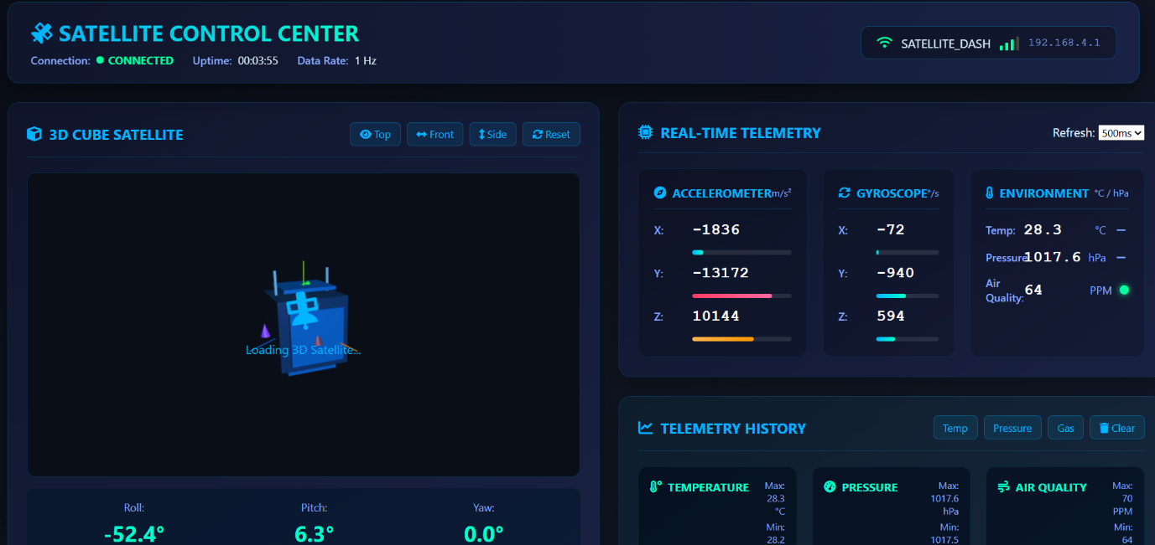

3.5 Thruster Simulation and Manual Control
The CubeSat is assumed to have 8 ionic thrusters at 8 corners.
Key design choices:
- Thrusters are simulated only
- Control is manual
- No AI-based automation
Reason:
Without a camera or hazard detection system, autonomous control could activate incorrect thrusters if an asteroid or obstacle is nearby, causing damage.
This reflects real aerospace practice:
Automation without sufficient sensing is unsafe.
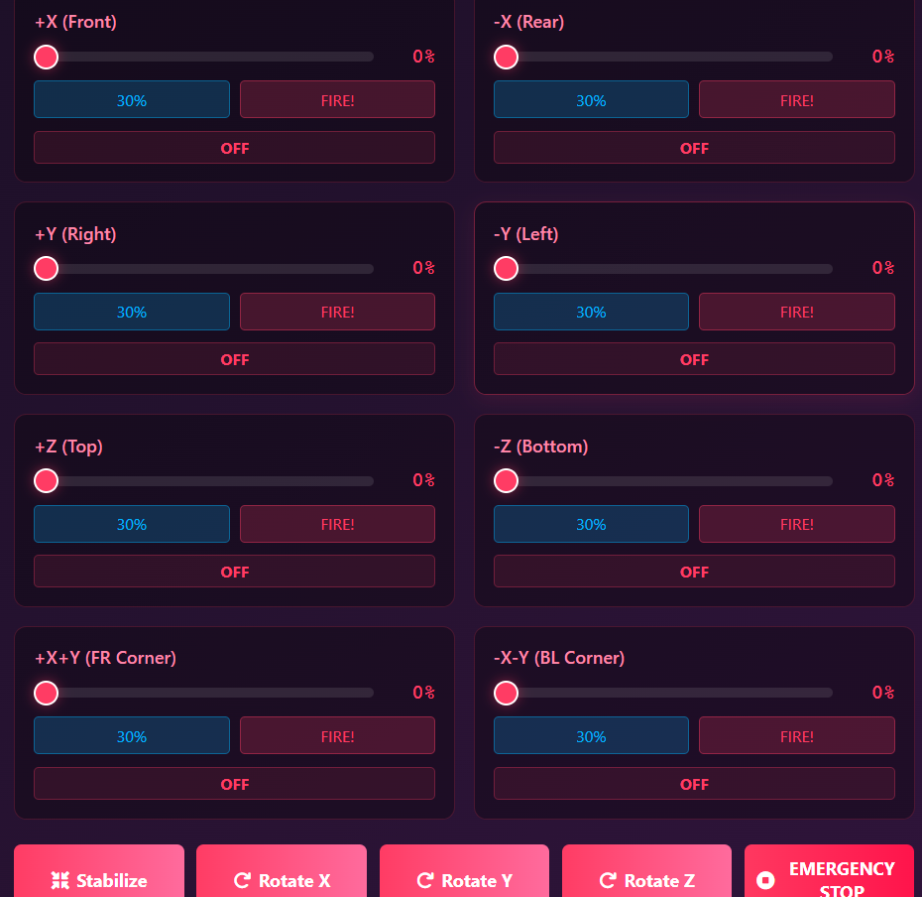
4. Subsystem 2: Satellite Gateway Communication
4.1 Objective
To demonstrate relay-based satellite communication without internet infrastructure.

4.2 Architecture
ESP32 (Node 1) <--> CubeSat <--> ESP32 (Node 2)
- Each ESP32 connects to a separate phone via hotspot
- Data is relayed using ESP-NOW
This simulates:
- Inter-satellite communication
- Relay satellites
- Store-and-forward communication systems
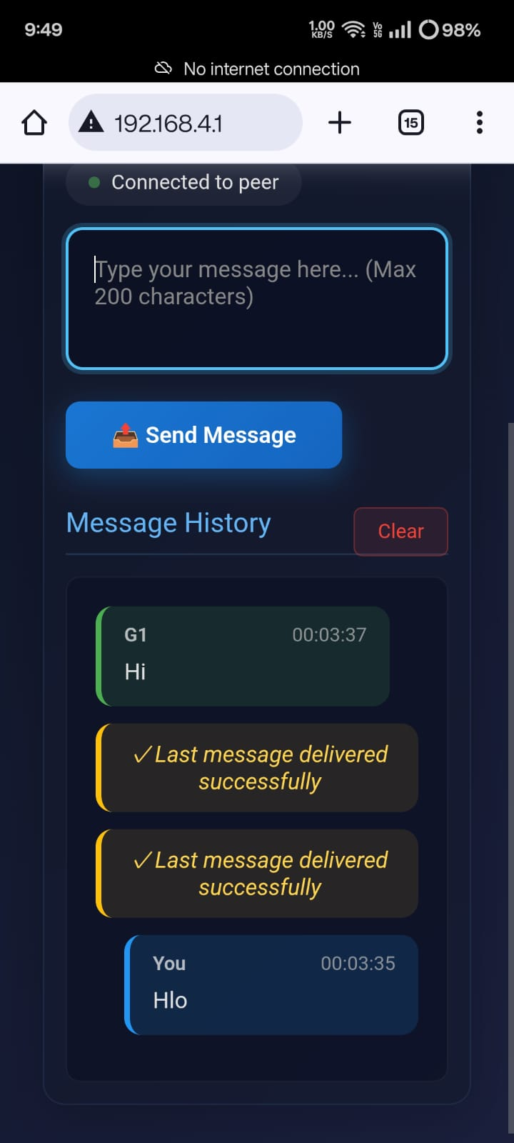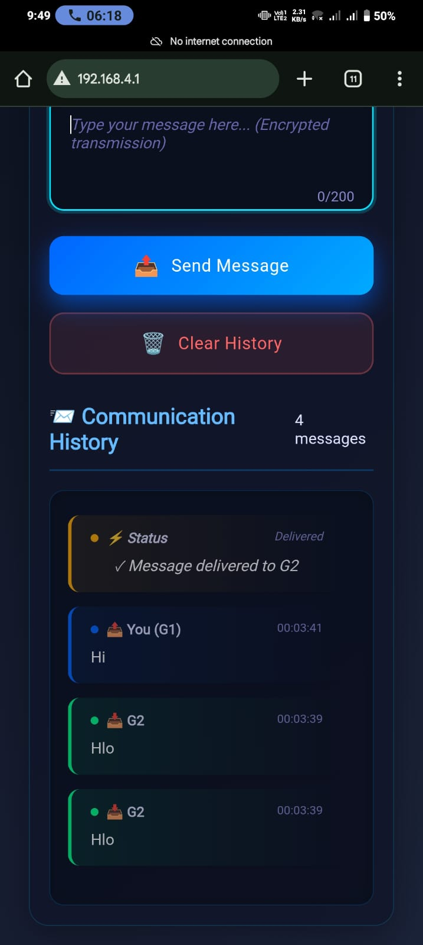

4.3 Applications
- Disaster communication in network-failed areas
- Military field communication
- Emergency response systems

5. Subsystem 3: RF Broadcast Listener and Encryption System
5.1 Objective
To listen to broadcast messages and handle corrupted, mixed, or noisy signals.

5.2 Broadcast Listening Concept
- NodeMCU listens to ESP-NOW broadcast messages
- Only messages matching device frequency are accepted
This simulates signal filtering in crowded RF environments.

5.3 Encryption Conversion Strategy
A dashboard converts typed messages into 35+ encryption techniques.
Important Design Decision:
- Messages are converted, not decoded
Reason:
In deep-space communication:
- Signals may be delayed
- Data may be corrupted
- Messages may overlap
By transmitting multiple encrypted combinations, the probability of reconstructing meaningful information increases. This approach is inspired by SETI signal analysis and redundancy-based communication.

6. Software and Tools Used
- Arduino IDE
- Embedded C
- ESP-NOW protocol
- Custom PC dashboard
- Serial and wireless data visualization

7. Results and Achievements
- Stable ESP-NOW communication
- Real-time sensor monitoring
- Accurate 3D orientation visualization
- Successful multi-subsystem integration
- Receiving broadcast signals
- Top 10 – AP Space Summit 2026

8. Limitations
- No onboard camera
- Thrusters are simulated
- Prototype-scale communication range

9. Future Enhancements
- Camera-based hazard detection
- Sensor fusion algorithms
- AI-assisted control with redundancy
- Long-range RF modules
- Advanced encryption and decoding

10. Conclusion
This project demonstrates a realistic, safety-focused CubeSat prototype emphasizing pre-launch testing, communication reliability, and system-level engineering. By avoiding unsafe automation and prioritizing validation and redundancy, the system aligns with real-world aerospace practices and provides a strong foundation for future satellite research.

11. References
- CubeSat Design Specification (CDS), California Polytechnic State University
- Espressif Systems – ESP-NOW Protocol Documentation
- NASA Small Spacecraft Systems Virtual Institute (SSSI)
- ISRO Student Satellite Programme (InSat-SSP)
- Wertz, J. R., Spacecraft Attitude Determination and Control
- SETI Institute – Signal Processing and Deep Space Communication Concepts

